Implement Application with Google App Engine (GAE)

Steps involved how to implement application with Google App Engine (GAE) below in the following order-
Step 1 - Install Eclipse IDE for Java EE Developers, version 4.8 or later. Install JDK 8 or JDK 11. Earlier and later versions of Java are not supported.

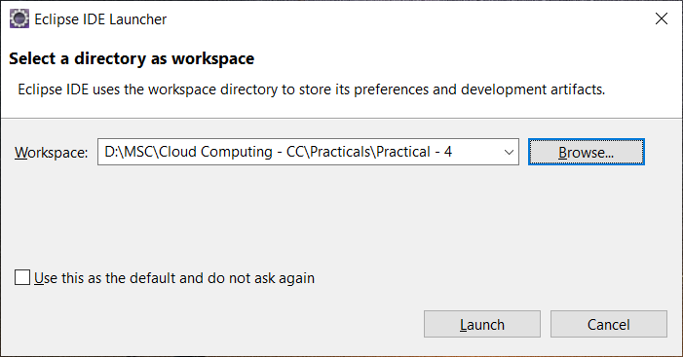

Step 2 - Click on -> Help -> Eclipse Marketplace.
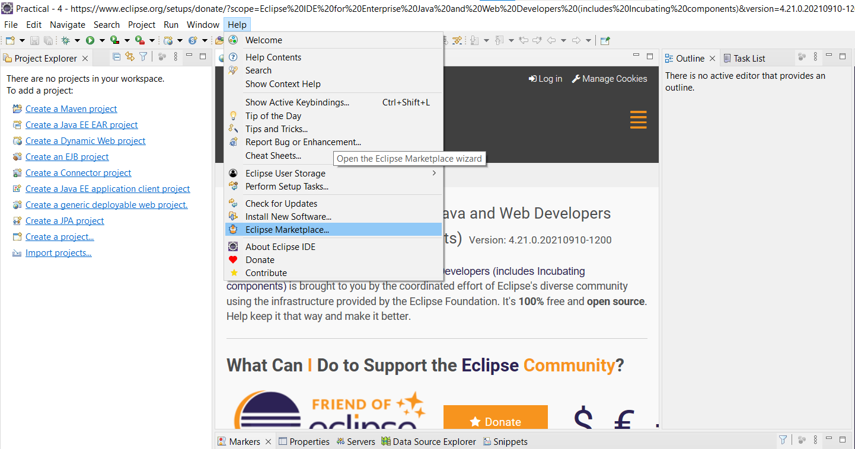
Step 3 - In Find Search Box: Search for “Google cloud tools for eclipse” and click on Install button. After complete installation of the plugin restart the Eclipse.
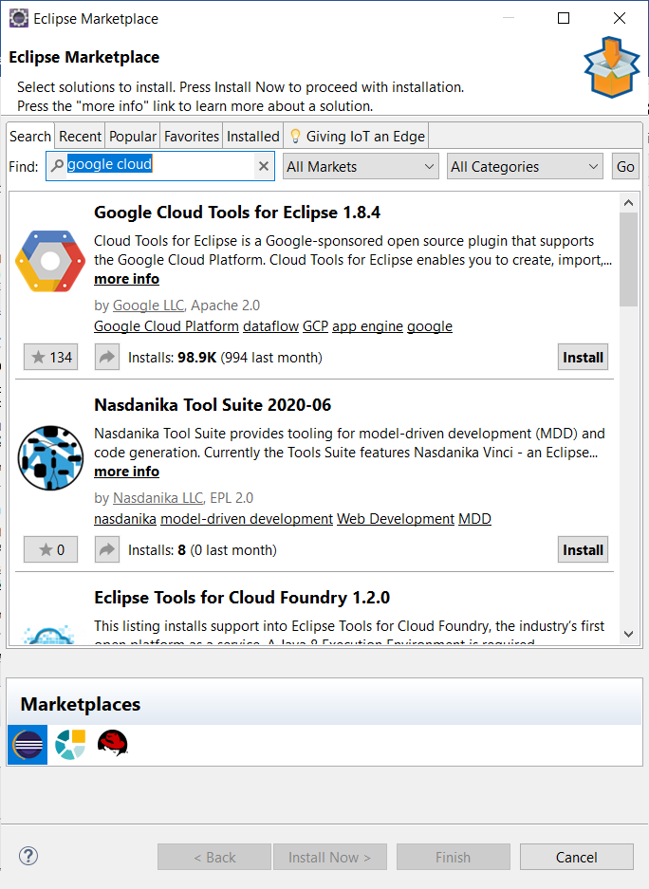
Step 4 - Click on ‘File’ menu and select -> New -> Other and search with “Google” keyword and select Google App Engine Standard Java Project under Google Cloud Platform and click on Next.
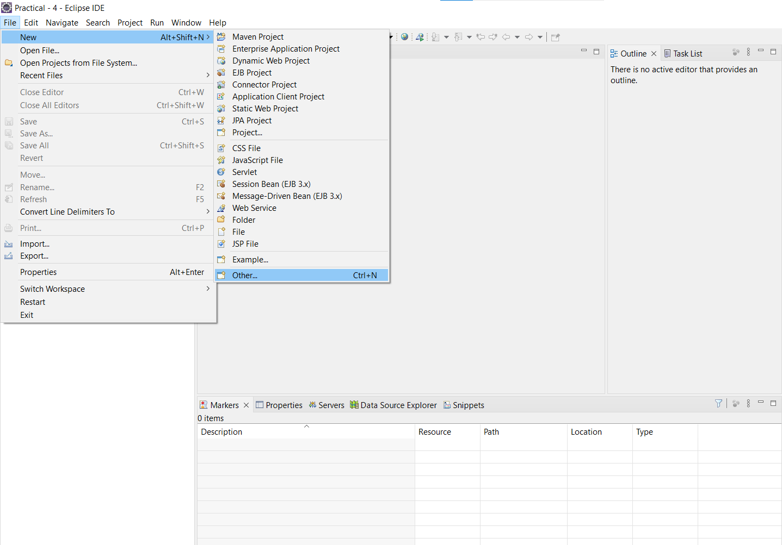
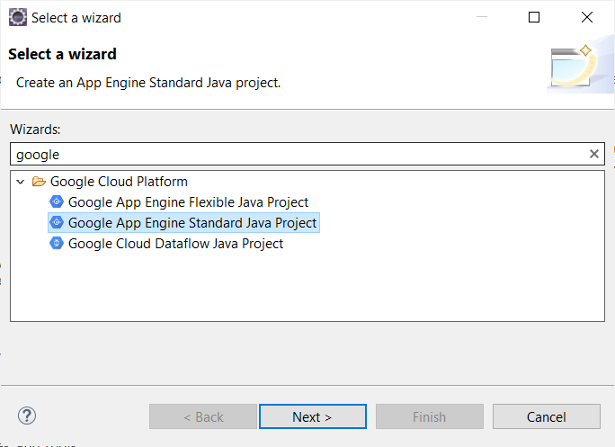
Step 5 - Enter Project Name “FirstGAEProject” and Package Name “com.GAE” and then Click on -> Next -> Finish.
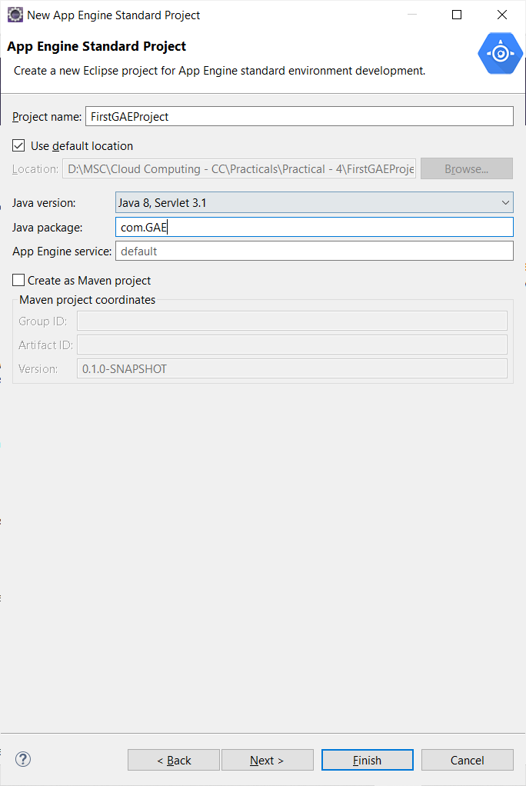
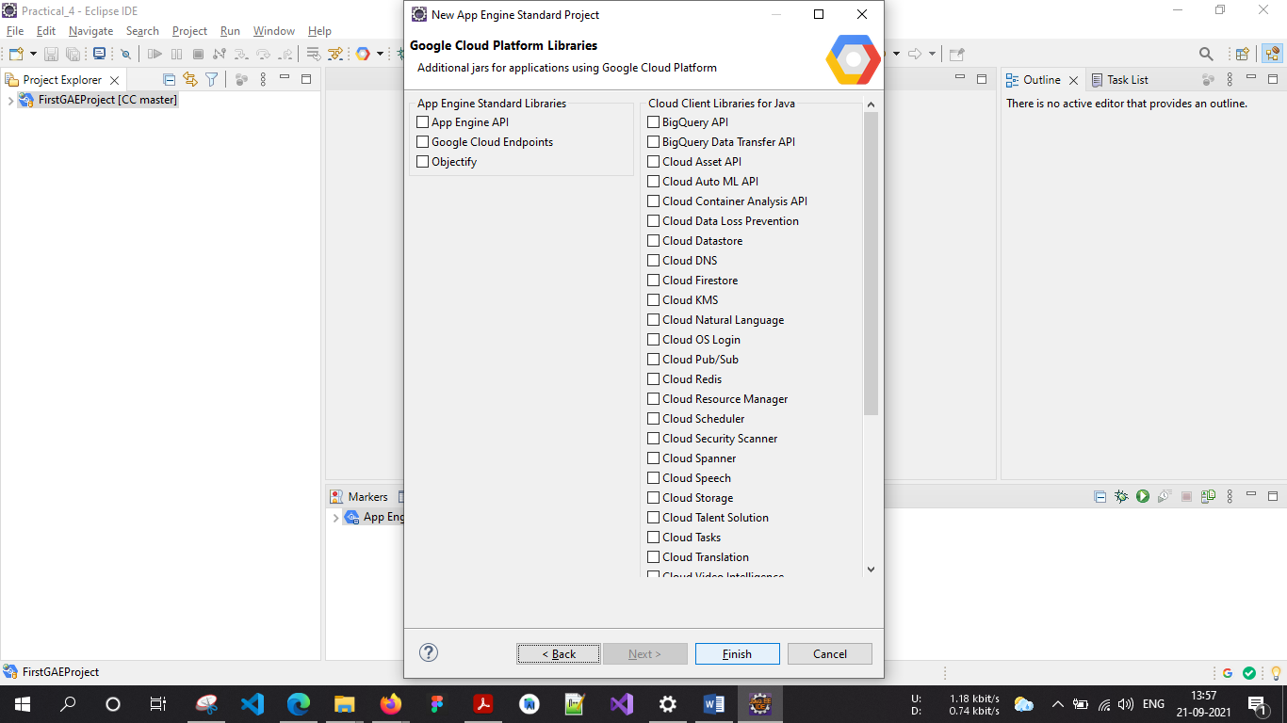

Step 6 - Open project hierarchy. (FirstGAEProject> main> webapp> WEB-INF> index.html) Edit the file as required (Unedited file too can be used. Here the editing is done to “what should be displayed” on the browser). Save the file. HelloAppEngine.java
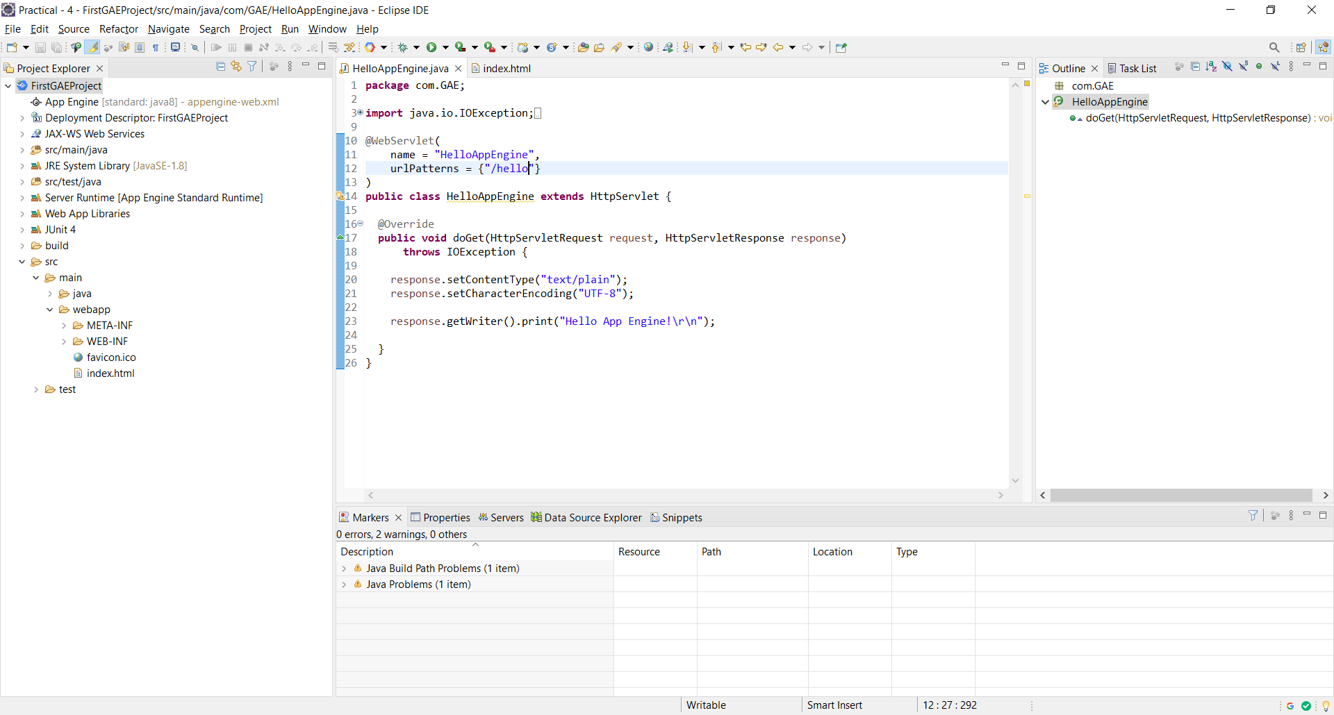

Step 7 - Configuring “App Engine Standard” Server. Click on the link to create a new server under Server tab.
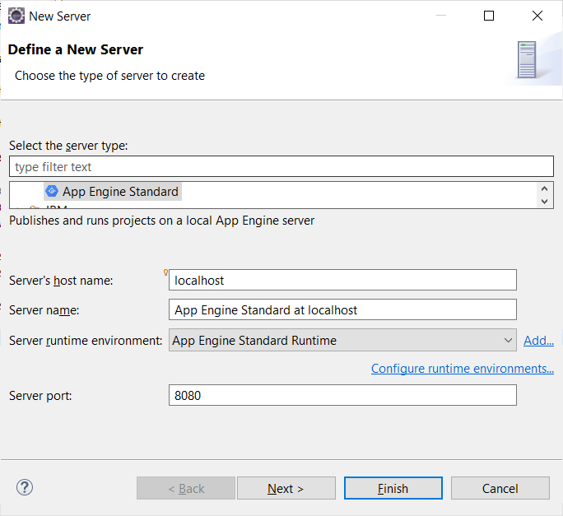
Step 8 - Add the “FirstGAEProject” and click on “Finish”.
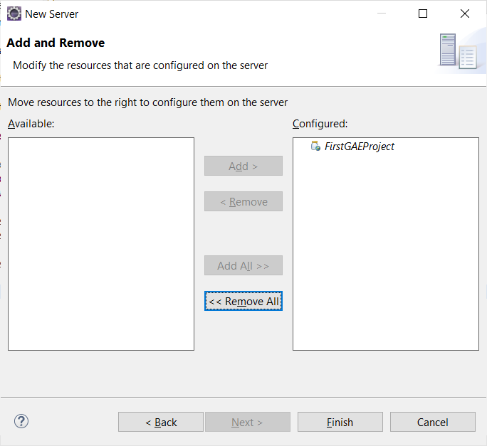
Step 9 - Start the “App Engine Standard” server.
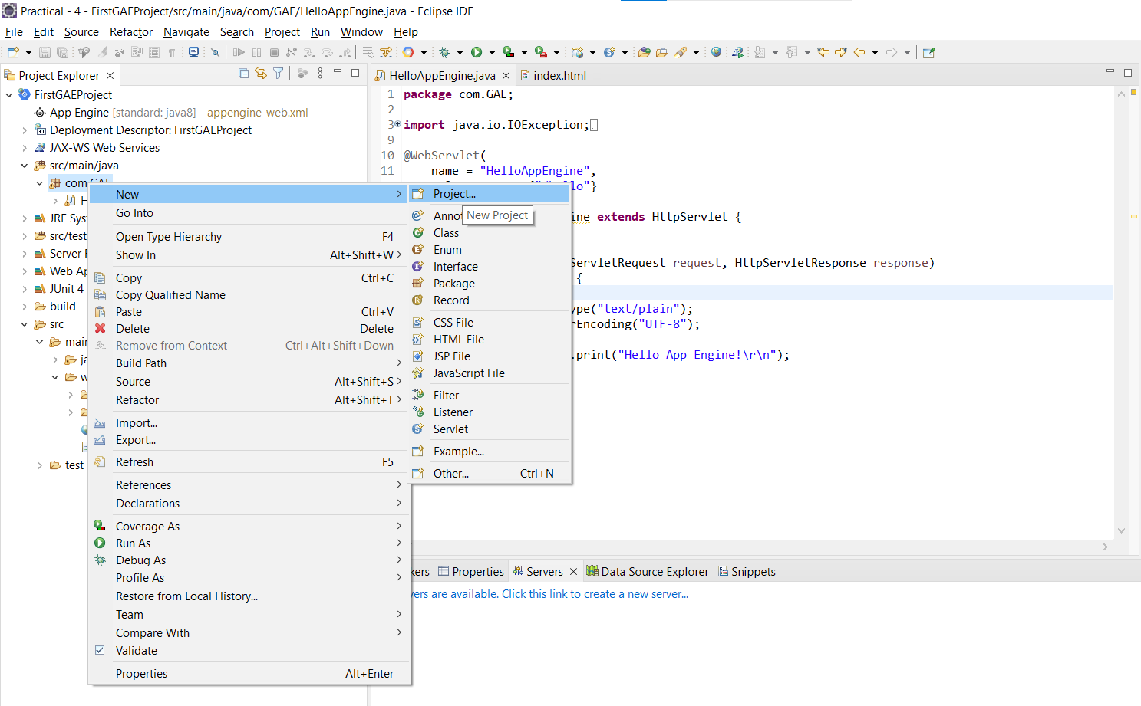

Step10 - Add the “FirstGAEProject” and click on “Finish”.
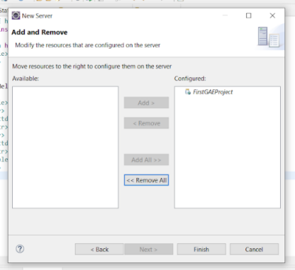
Step11 - Start the “App Engine Standard” server.
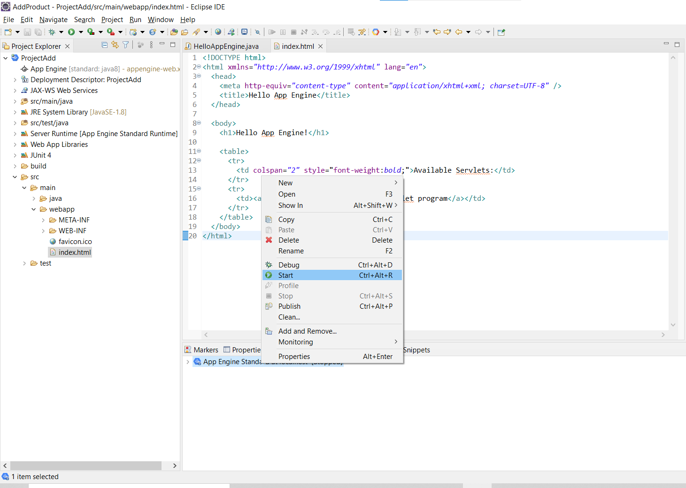
Step12 - In the browser (Here, Google Chrome) type the address as “localhost:8080” which is "Default" for http protocol.
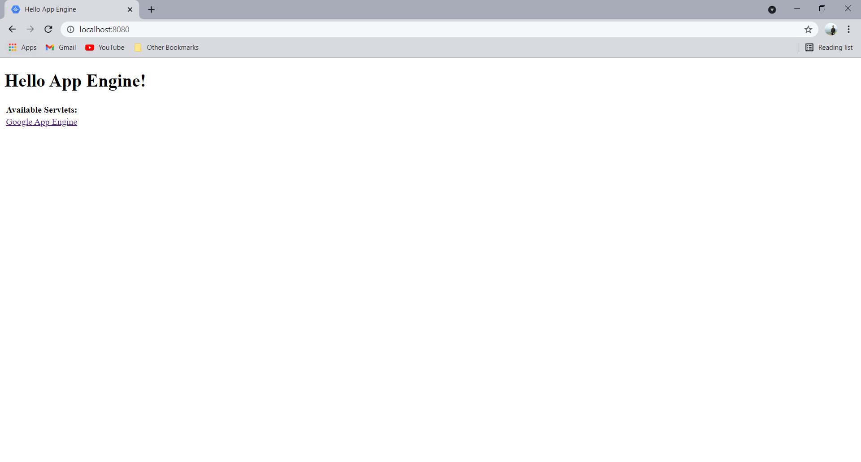
Step13 - Click on this link “Google App Engine”. It will redirect with the address “localhost:8080/hello”.
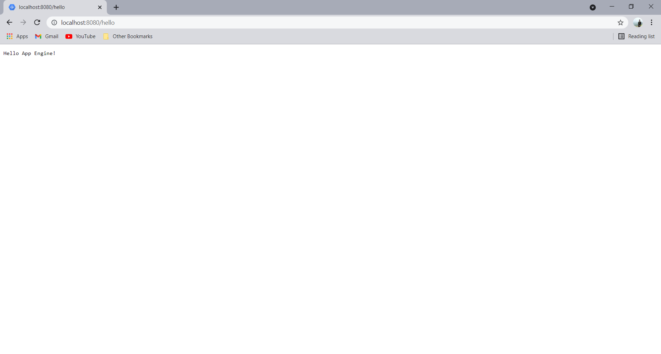

- Design and implement Google app search engine to Add and to find product of two Numbers –
Step1 - Create a new project. File-> New-> Other...
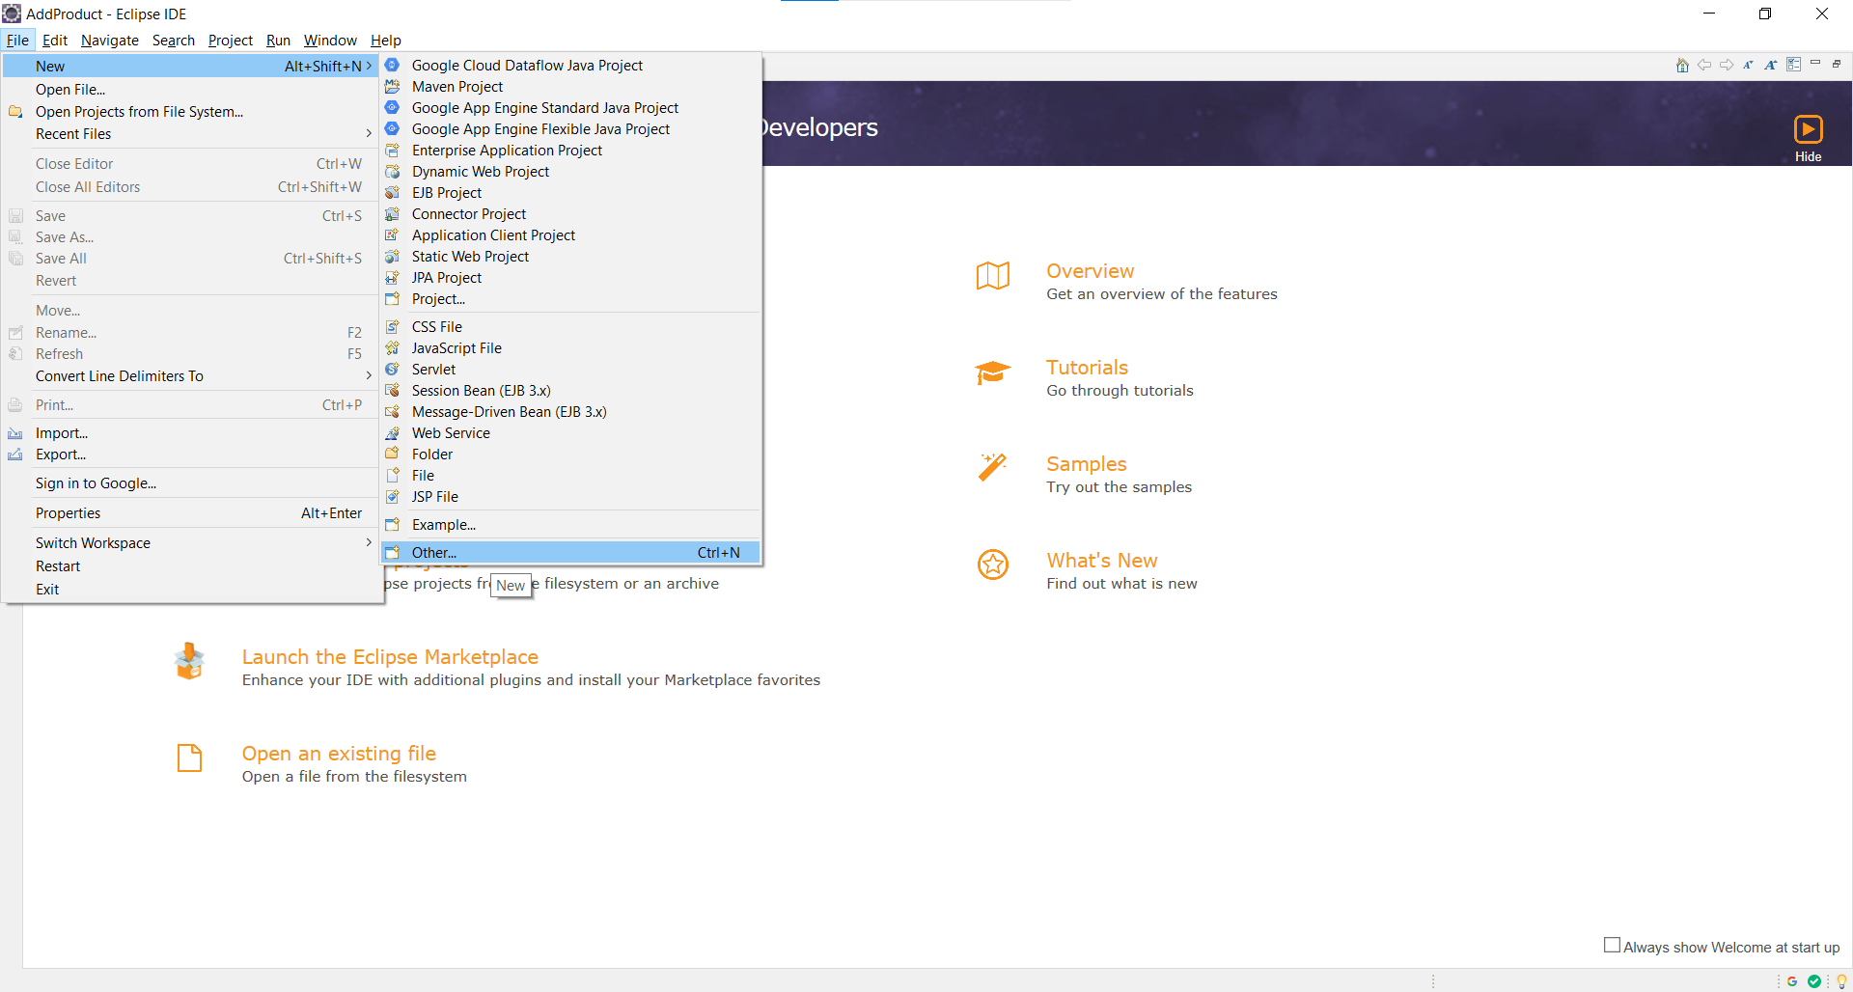
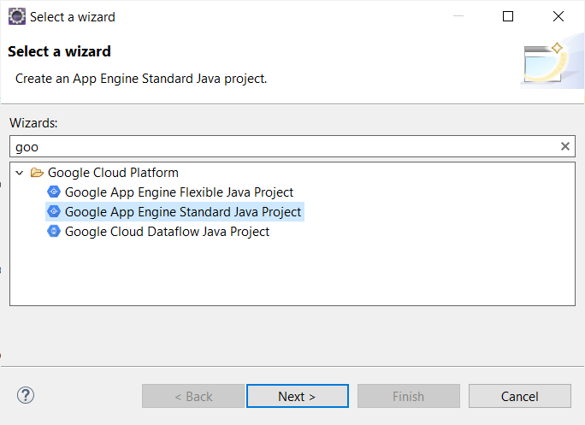

Step 2 - Enter Project Name “ProjectAdd” and Package Name “com.GAE” and then Click on -> Next -> Finish.
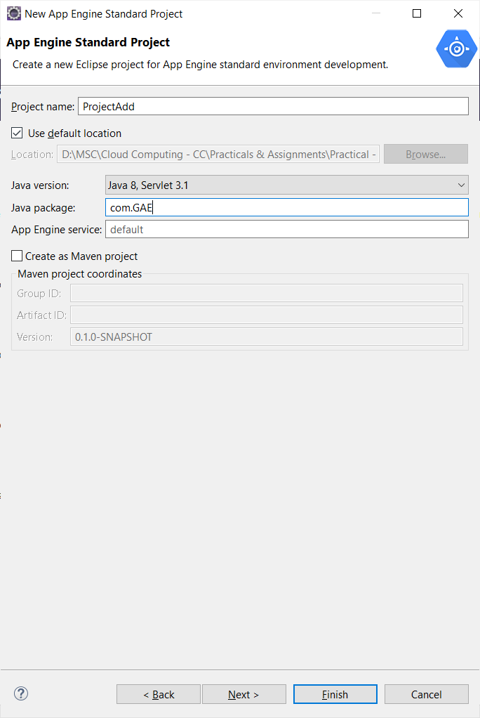
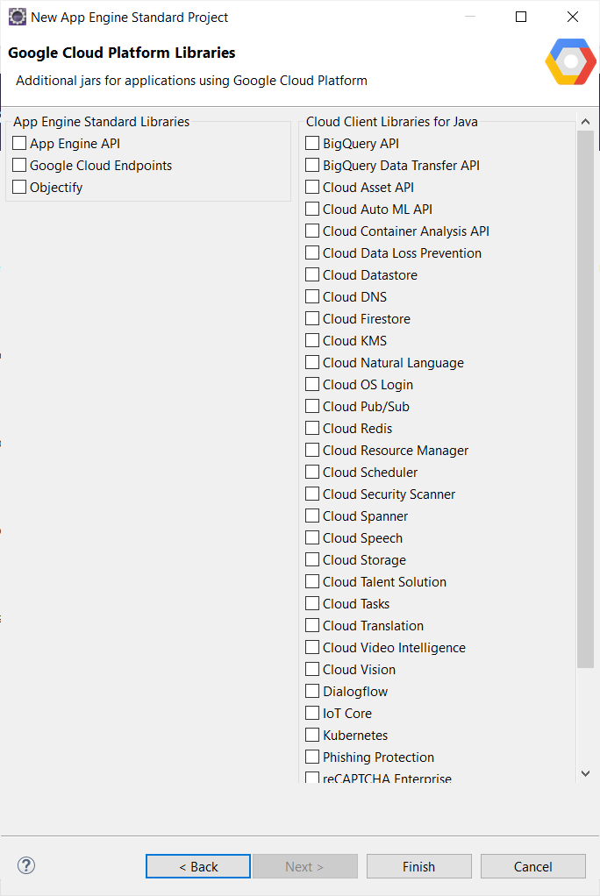
HelloAppEngine.java
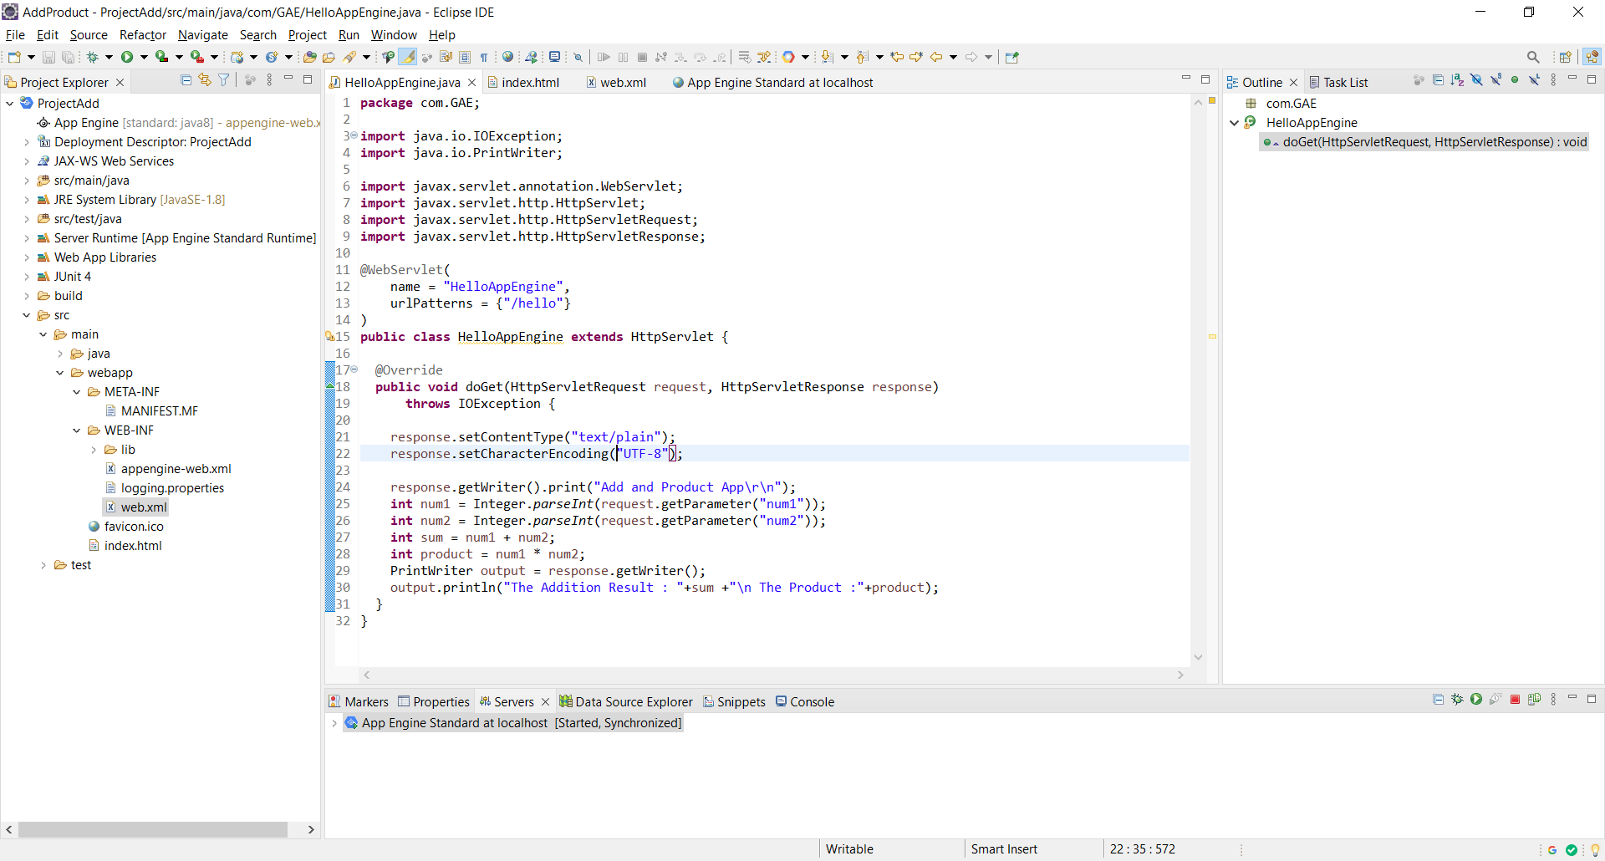
Index.html
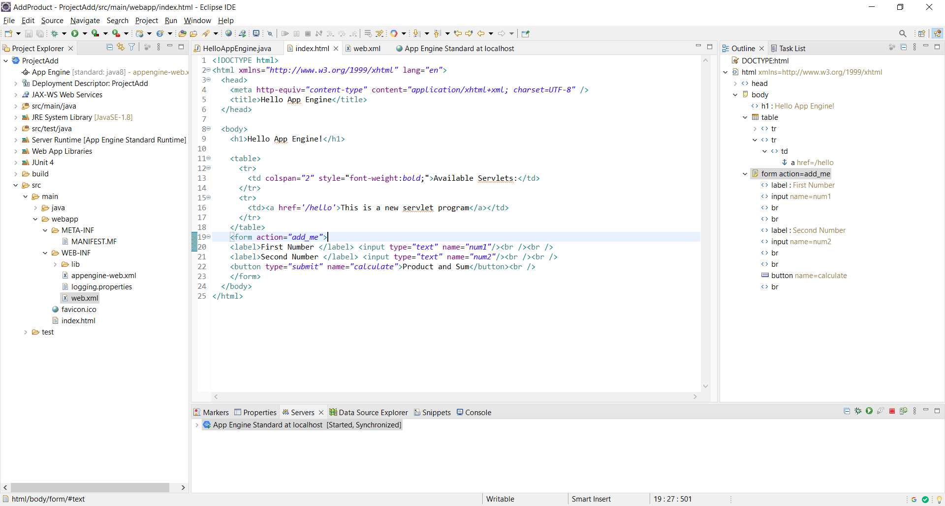

Web.xml
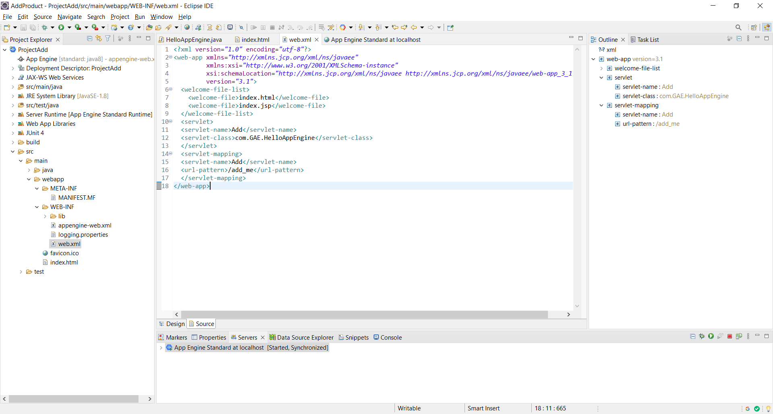
Step 3 - Configuring “App Engine Standard” Server. Click on the link to create a new server under Server tab.
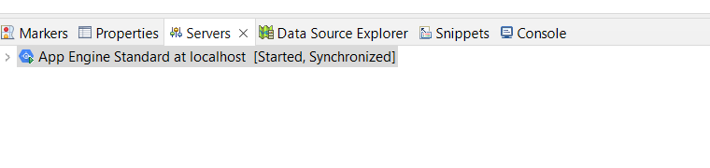
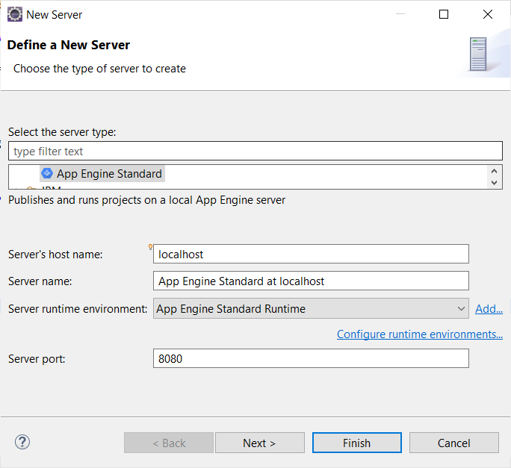
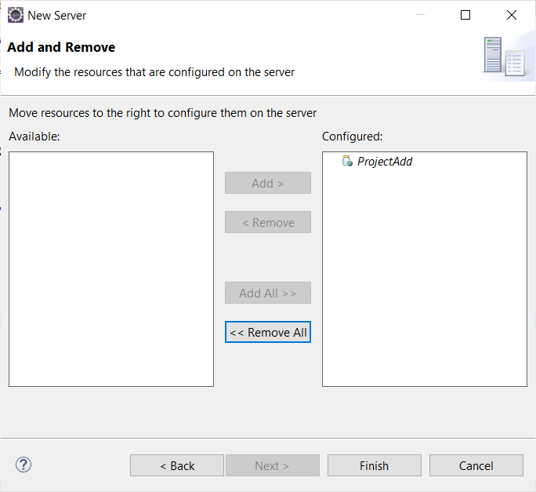

Step 3 - Start the “App Engine Standard” server
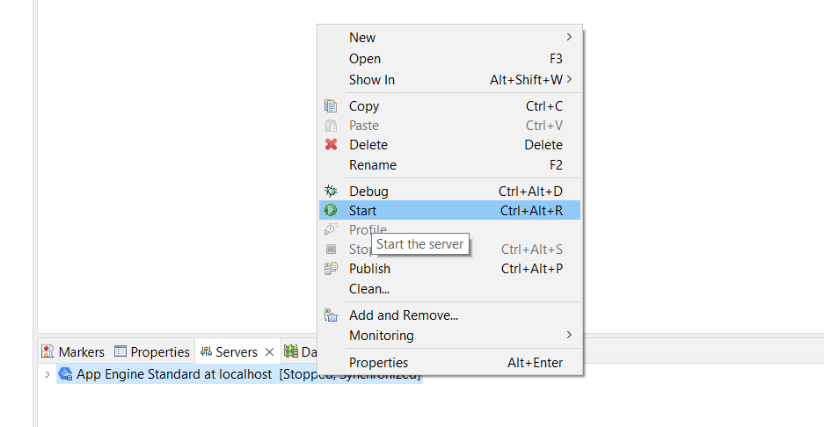
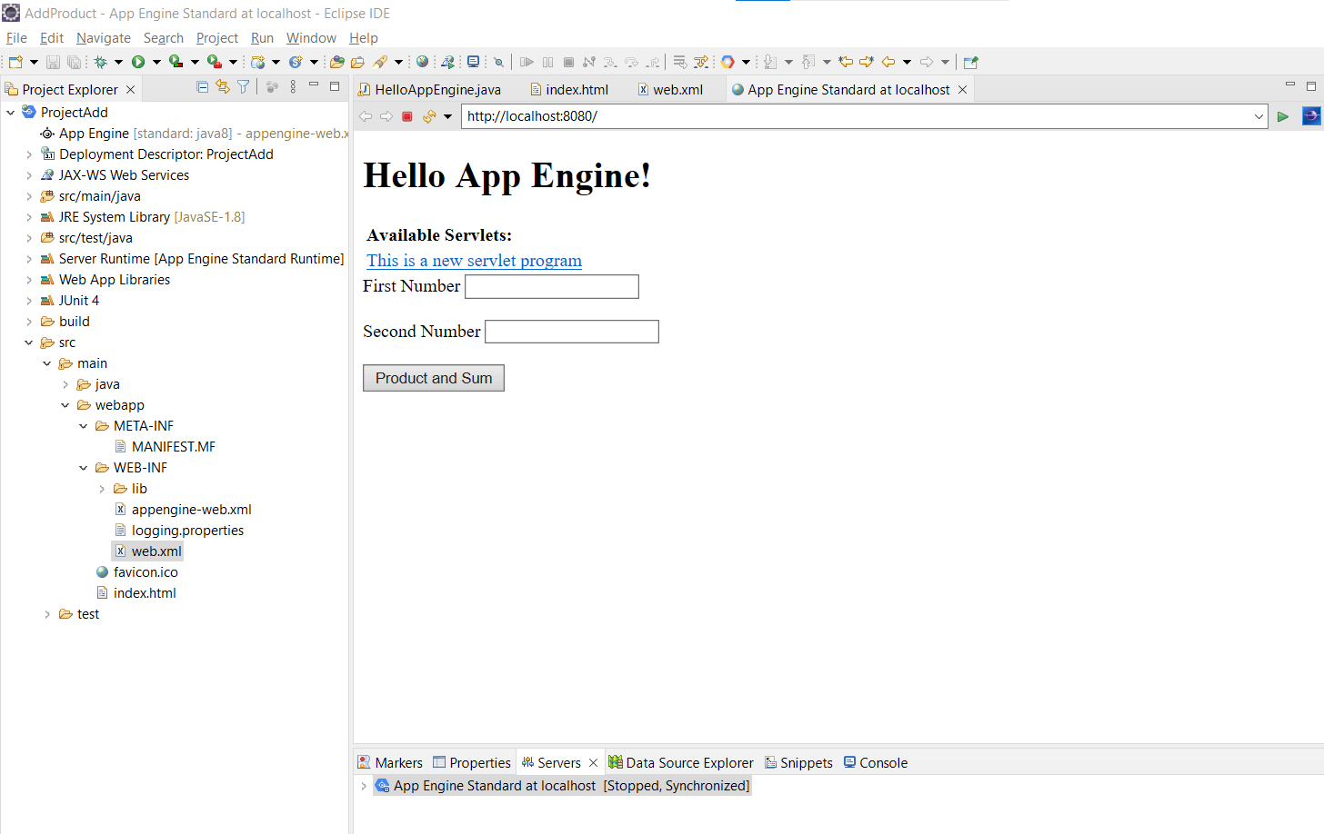

Step 4 - In the browser (Here, Google Chrome) type the address as “localhost:8080” which is "Default" for http protocol
